SQL ASSESSMENT-1

TOPICS : **Execute OVER and PARTITION BY Clause in SQL Queries ,creating subtotals &Total Aggregations using SQL Queries.**

**STEP 1: CREATED DATABASE “sqlassessment” AND USING THE DATABASE “sqlassessment”**

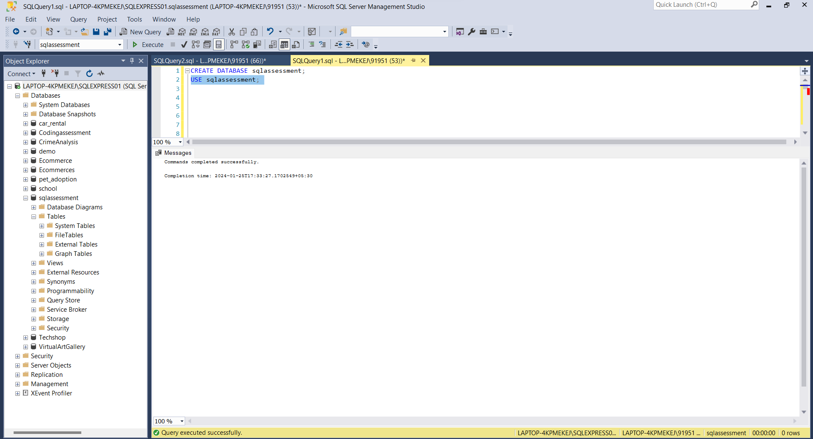

STEP 2: CREATED AND INSERTED VALUES INTO THE TABLES.

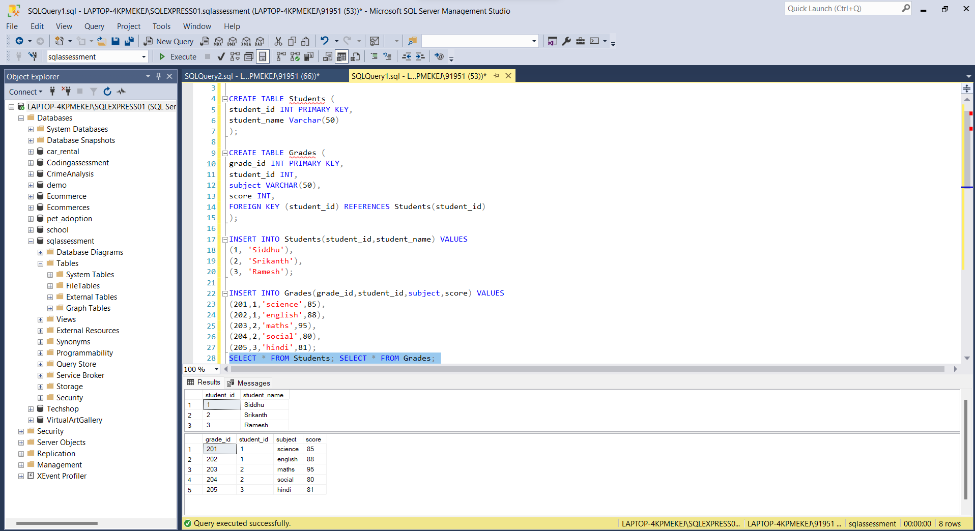

STEP 3: EXECUTING WITH OVER AND PARTITION BY

OVER: It allows you to perform calculations that involve multiple rows, like aggregations or rankings, without grouping the entire result set.

PARTITION BY : PARTITION BY is used in conjunction with OVER to divide the result set into partitions or groups based on one or more columns.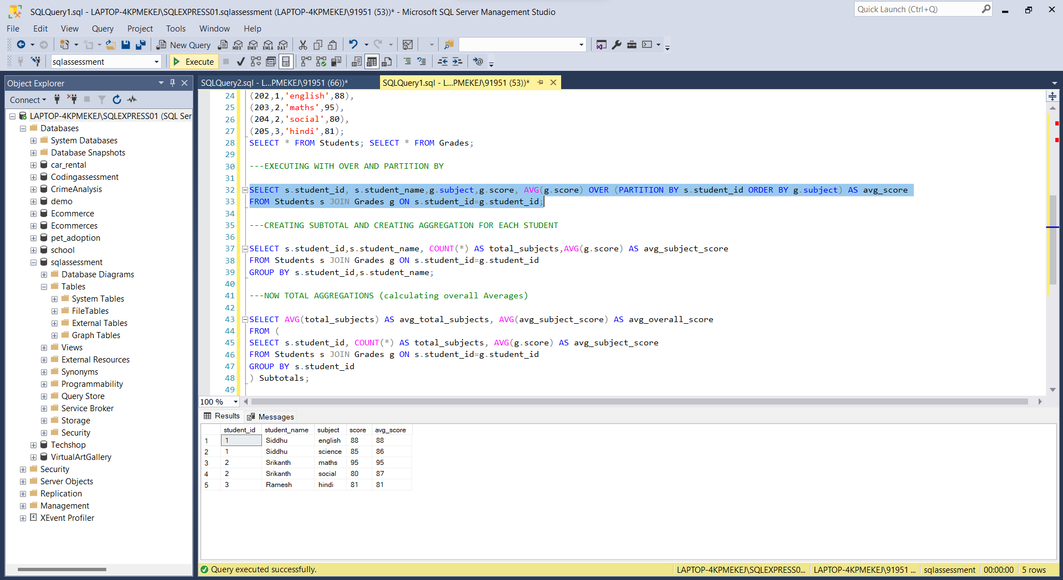

STEP 4: CREATING SUBTOTAL AND AGGREGATION:

Creating subtotals in SQL involves using aggregate functions along with the GROUP BY clause. It divides the rows. After Grouping we can use aggregate functions like AVG, SUM Etc.

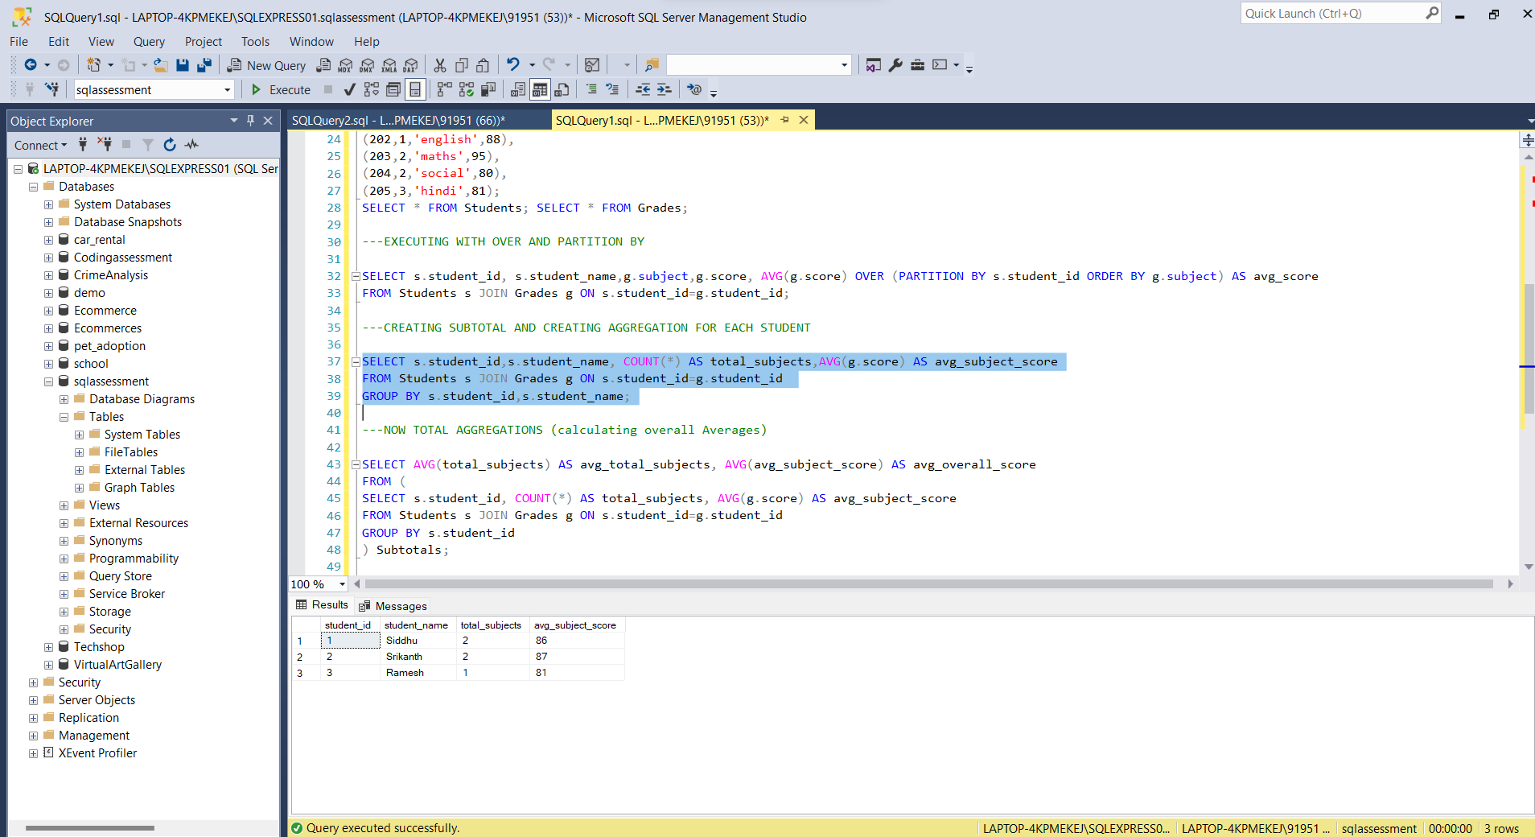

STEP 5 : TOTAL AGGREGATION

